Momentum 1927-2014 Regression Analysis
Name
Institution
Date

Momentum 1927-2014 Regression Analysis
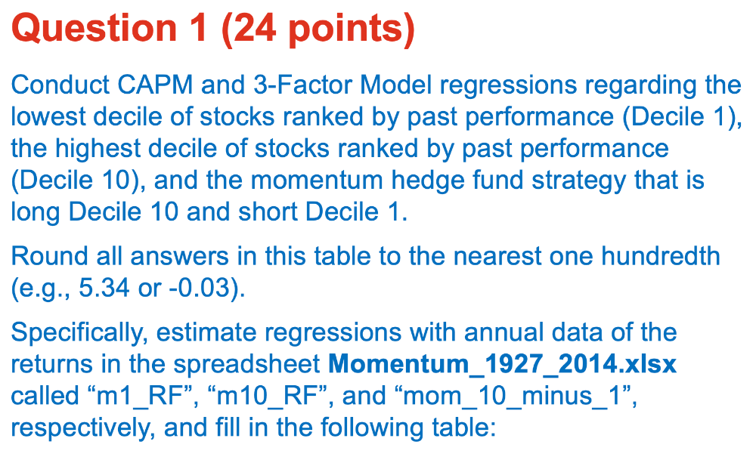
Question 1:
 | PAST LOSER  Decile 1 | PAST WINNER  Decile 10 | LONG/SHORT  (10-1)
Alpha from CAPM (Yearly) | -10.98 | 6.72 | 17.7
Beta CAPM | 1.37 | 1.20 | -0.17
R-Squared | 0.72 | 0.79 | 0.02
Alpha from 3FM (yearly) | -11.60 | 7.71 | 19.39
Beta on Market Factor | 1.22 | 1.15 | -0.07
Beta on Size Factor | 0.54 | 0.28 | -0.27
Beta on Value Factor | 0.00 | -0.30 | -0.30
R-Squared | 0.76 | 0.82 | 0.07

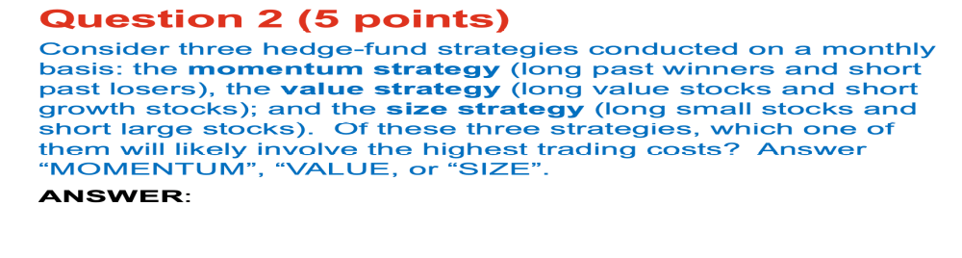
Question 2:
- Momentum Strategy:-
This is because a momentum hedge-fund strategy involves buying past winners and shorting past losers thereby an investor tend to purchase a stock with the highest price return over a specified period and undertake regular rebalancing, which contributes to high trading costs
Question 3:
- No:
The negative and small market beta (-0.17) indicates an inverse as well as weak relationship that involves the performance of the security to the volatility in the market. Therefore, the security may fail to replicate the positive returns on average in the future because of the minimal relationship between returns and the risks in market. For example, the investor may fail to capitalize on future increases in market volatility that generates positive returns because of the low market beta (-0.17).

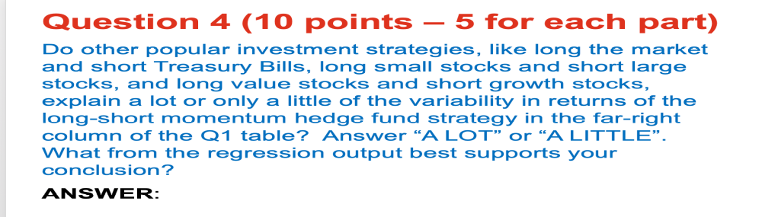
Question 4:
- A Little Variability in Returns:
- R-Squared output of 0.07 and Alpha from 3 Factor Model Regression of 19.39
The R-Squared output of 0.07 implies a minimal variability in return because only 7% of the fund’s performance can be explained by its risk exposures. Equally, the yearly coefficient of 17.7 Alpha from 3 Factor Model implies the existence of little variability in returns of a Long-Short Momentum strategy because the fund performed better than the predicted CAPM by a meager 17.7%.

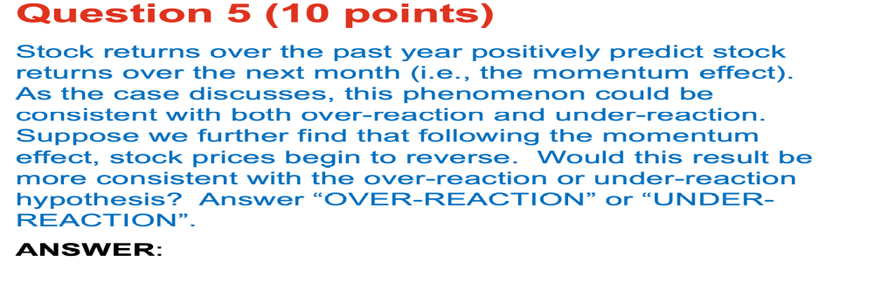
Question 5:
- “Under-Reaction”
Hypothesis (Ho): ‘Investor under-reacts to earning surprises’
The fund experience minimal exposure to the SMB, HML, and Market Beta factors, which indicate lack of aggressiveness to generate more volatility (market risk) necessary to earn more compensation. The fund has negative t-statistic test for the SMB, HML, and Market Beta -1.32,-1.64, and -0.52 respectively that support an under-reaction hypothesis. Further, the fund has a small F-Stat value of 2.25 that helps to uphold the hypothesis about under-reaction.
Question 6:
- “LARGE STOCKS”
- Beta on Size Factor of 0.28 (SMB) best support the conclusion that the fund tilts toward a large capitalization because the coefficient loading is less than 0.5 and closer to 0.
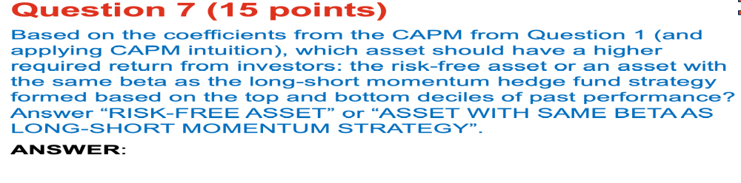Question 7:
- “Risk-Free Asset”
As at October 31, the U.S. Treasury Bills, which represent the risk-free asset, was quoted at 2.19 and a coupon equivalent of 2.68% (U.S. Department of the Treasury, 2018). Therefore, a Risk-free asset with a coupon rate of 2.68% guarantees a higher expected-required than a security with a market beta of 1.37 and 1.20 for a long-short momentum fund.

Question 8:
A momentum investing strategy borrows its fundamental principle from a Physics term ‘momentum’, which implies that a mass-body in motion tend to maintain its status. The key attributes that attract momentum investing include an assumption that investors are slow to learn and assess the influence of current information about a security (Brightman, 2015). Therefore, conventional investors tend to learn by observing others, which helps to create interest and attract prospective investors to a particular asset. Equally, a momentum investor seeks to capitalize on the recency biases that are characterized by the tendency to overemphasis recent information over the past trends (Patil, 2012). The recency biases help to sustain the upward or downward price movements of a security asset (ibid). The three distinctive attributes of a momentum investment strategy accord an investor with advantages and limitations that include profitability as well as downward crushing respectively
A core advantage of offering a momentum-mutual fund relates to profitability because of the robustness of the investment strategy. The tendencies of the securities that exhibit above-average performance to sustain short-term excesses enhance the robustness and profitability of a momentum investing (Brightman, 2015). An investor capitalizes on the capital gains achieved by acquiring a security with rising prices and disposing of such portfolio at a relatively higher price (ibid). An investor needs to acquire the necessary skills to predict an appropriate time to dispose of the security before the manifestation of a reversal trend.
Importantly, predicting the turning point in a momentum-mutual fund provides a major limitation. The downsides of a momentum investment strategy entail detrimental drawdowns and over-crowding, which hamper the ability to scoop the intended returns in the long-term (Patil, 2012). For example, the drawdowns emanate from increased market volatilities, which force an abrupt reversal of the steadily rising security price. The recent volatilities in the U.S. market include the ‘dot.com bubble burst’ moment in the 2000s and the financial crunch of 2008. On the other hand, overcrowding in a momentum trading is apparent when more investors strive to capitalize on the momentum booms and result in oversubscriptions (Brightman, 2015). The crowding phenomenon contributes to a reversal trend because of the low returns that emanate from the imbalances of the market forces.
Therefore, the AQL Team resolves to avoid launching a momentum-mutual fund to the retails because the limitations surpass the benefits. Notably, the conventional retailers lack the prerequisite level of skills necessary to adopt an active momentum approach because of the need to monitor the market parameters that aid to predict the turning point of an upward trend (Patil, 2012). Secondly, managing a momentum-mutual fund increases the transaction cost that includes brokerage fees because of the high frequency of trading inherent in a momentum investment strategy (ibid). Moreover, a momentum-mutual fund generates significant returns in a short-term time perspective and hampers the attractiveness of such security to conventional investors who prefer investments with long-term returns.

References
U.S. Department of the Treasury. (2018). Resource Centre. Retrieved from www.treasury.gov/resource-center/data-chart-center/interestrate/page.aspx? [ACCESSED October 30 2018]
Patil,G. (September 21, 2012). “Should you be Chasing Momentum Stocks?” The Moneyworks. Retrieved from www.moneyworks4me.com/investmentshastra/stock-investment/should-you-go-for-momentum-investing/ [ACCESSED October 30 2018]
Brightman, C. (September 29, 2015). “Research Affiliates: How not to wipe out with momentum,” The EFT.Com. Retrieved from www.etf.com/sections/features-and-news?nopaging=1[ACCESSED October 30 2018]

